Eventi
Use Case Specification

Submitted to:

Asst. Prof. Ma. Rowena C. Solamo
Faculty Member
Department of Computer Science
College of Engineering
University of the Philippines, Diliman

Submitted by:
Dimaano, Aaron Diego I.
Lopez, Matthew S.
Torres, Jacob Angelo V.

In partial fulfillment of academic requirements
for the course
CS 191 Software Engineering I
of the
1st Semester, AY 2015-2016
Unique Reference:
The documents are stored in https://github.com/Tom-2013-06417/CS191-192_Event_Sharing/tree/master/02-Requirements%20Engineering.
Link to this document: https://github.com/Tom-2013-06417/CS191-192_Event_Sharing/blob/master/02-Requirements%20Engineering/13.0%20-%20Manage%20own%20events.pdf.

Document Purpose:
The purpose of this document is to exhaust the step-by-step process of the Use Cases in every scenario possible.

Target Audience:
To our project client and adviser, our fellow 191 classmates, and our future selves when they need to refer back to this document.

Revision Control:

Revision Date | Person Responsible | Version  Number | Modification
09/18/15 | Dimaano, Diego  Lopez, Matthew  Torres, Jacob | 1.0 | Initial Document

Use-Case Name: Manage own event

Description: This feature lets the organization edit the event once it has been uploaded. Whenever there has been a change in the specifications of the event, the organization has the opportunity to edit the information.

Preconditions: There is an internet connection to the Eventi server and a device with browsing capabilities. A registered user that has permission to operate an organization must be currently logged into the site.

Flow of Events:

Scenario Name | Description
Scenario 1 (Basic Flow)  Organization wants to edit information from the event | 1. Registered User clicks an event it has uploaded and selects the edit option  2. Registered User changes the data it wanted to change  3. Registered User saves changes and closes the edit option

Activity Diagram of the Flow of Events:

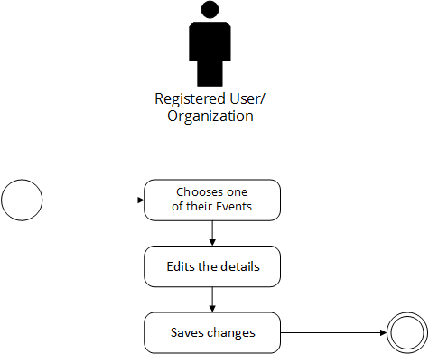

Post-conditions: Successful: The event’s changes were also recorded and reflects on other user’s home pages.
Failed: The event’s changes were not saved.

Special Requirements: NONE

